MHA Ramayya – Infrastructure / SRE Intern Assignment
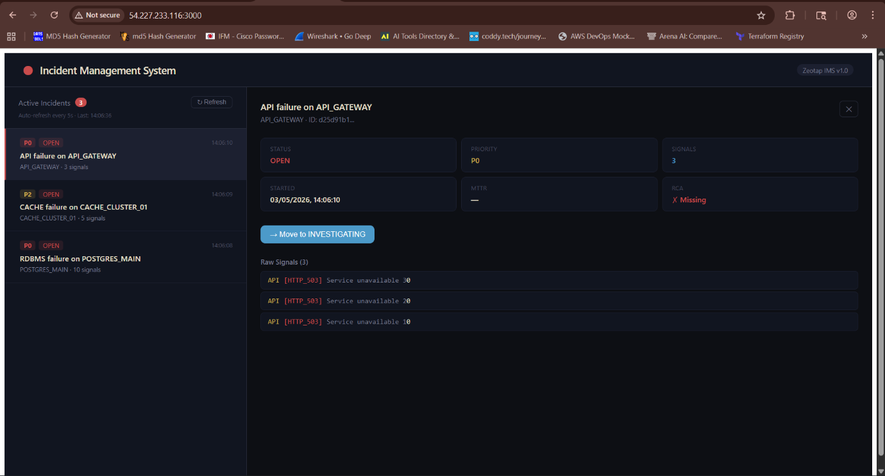
1. Project Overview
This project implements a production-style Incident Management System (IMS) with a complete DevOps lifecycle: CI/CD, monitoring, observability, and containerization. It demonstrates automation, resilience, and scalable deployment practices.
2. GitHub Repository
https://github.com/babai-cyber/ims.git
3. Architecture Diagram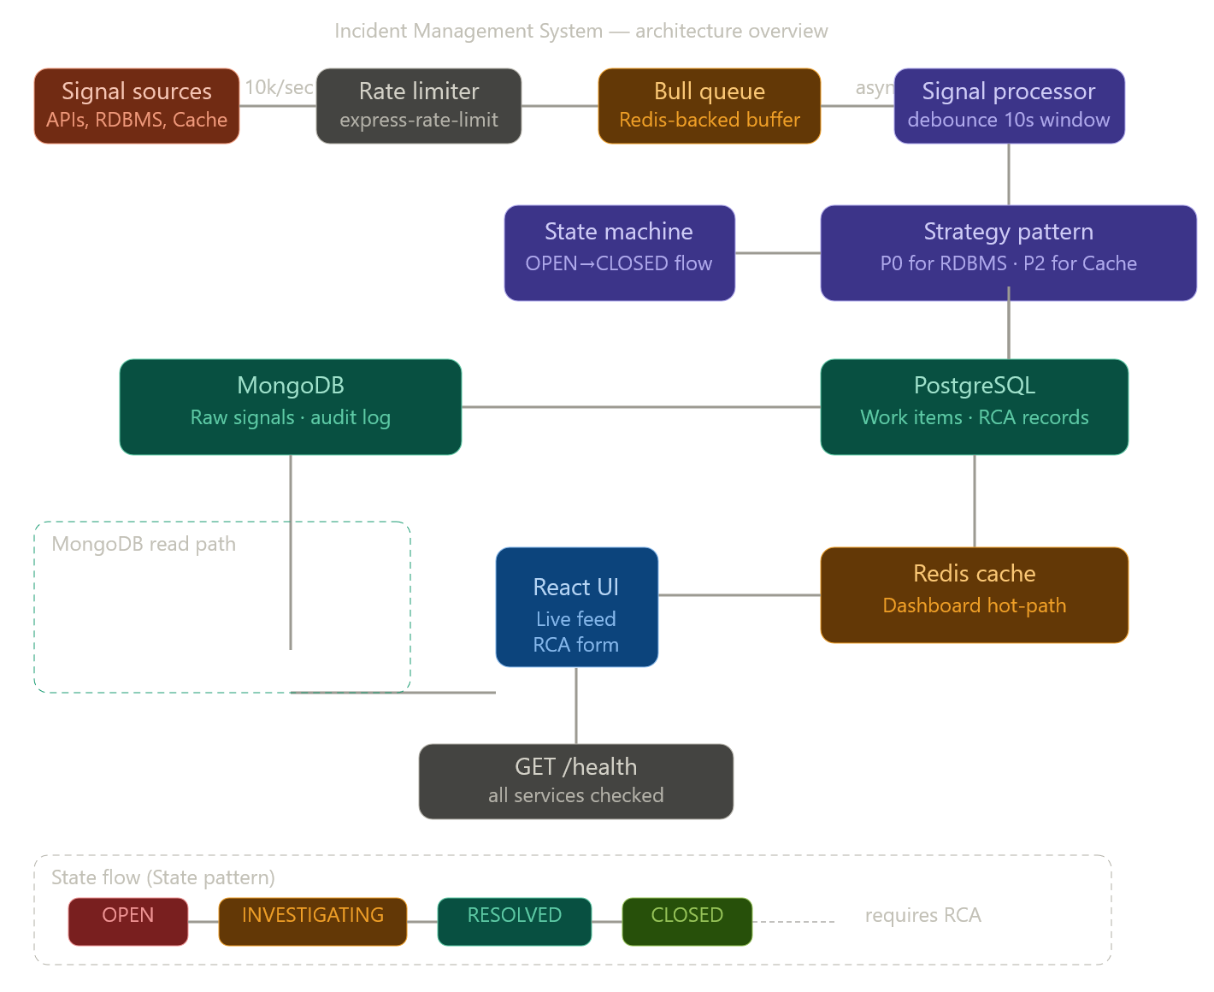

Frontend (React + Vite) → Backend (Node.js + TypeScript + Express) → PostgreSQL (Work Items + RCA) + MongoDB (Raw Signals) + Redis (Cache + Queue) All services are containerized with Docker Compose and orchestrated via Jenkins CI/CD. Monitoring is powered by Prometheus + Grafana.
4. Architecture Explanation
- Frontend: React dashboard auto-refreshing every 5s, showing incidents and RCA forms.
- Backend: Node.js API with Bull queue for backpressure, Redis debounce logic, PostgreSQL for transactional state, MongoDB for raw signals.
- Databases: PostgreSQL (ACID transactions), MongoDB (TTL audit log), Redis (cache + queue).
- Design Patterns:
  - Strategy Pattern → P0 alerts for RDBMS/API, P2 alerts for Cache/Queue.
  - State Machine → Enforces OPEN → INVESTIGATING → RESOLVED → CLOSED lifecycle.
5. CI/CD Pipeline (Jenkins)
Before webhook trigger :
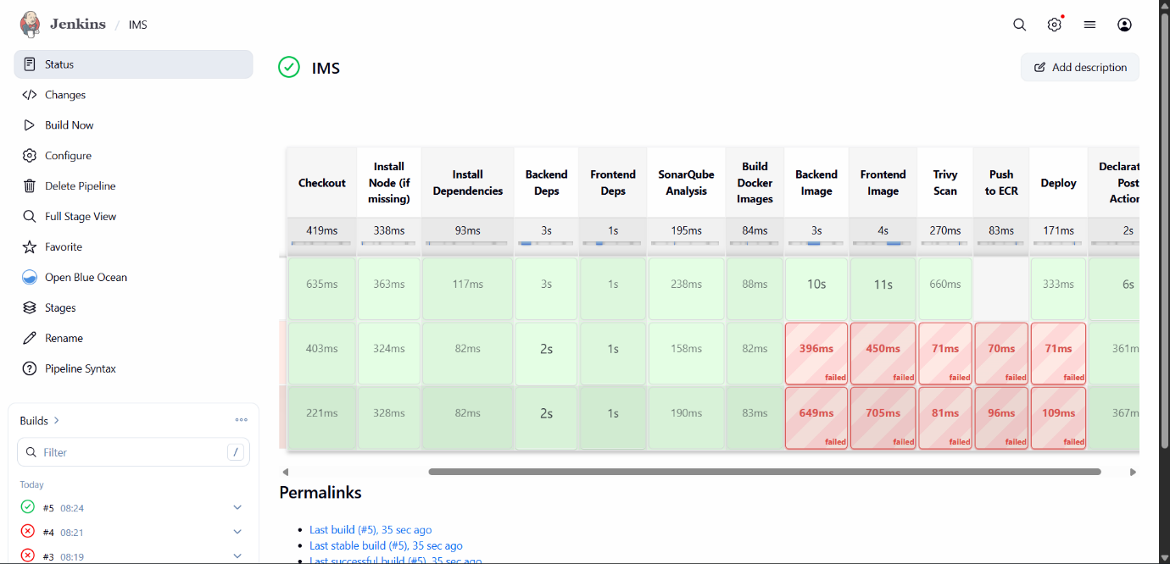
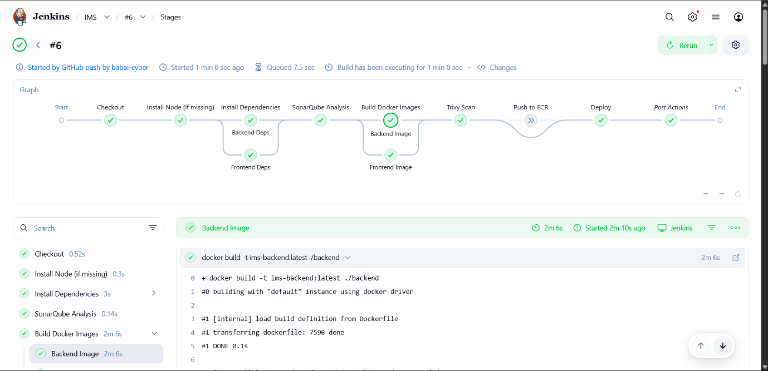
After Webhook trigger:
Stages:
- Checkout (GitHub webhook) : https://github.com/babai-cyber/ims.git
- Install Dependencies (npm ci)
- Build (TypeScript compile)
- Unit Tests (Jest for RCA/state machine/debounce)
- SonarQube Analysis (Quality Gate enforcement)
- Trivy Scan (Docker image CVE scanning)
- Docker Build & Push (Docker Hub/ECR)
- Deploy (EC2 via docker-compose)
- Health Check (/health endpoint)
6. Monitoring (Prometheus + Grafana)
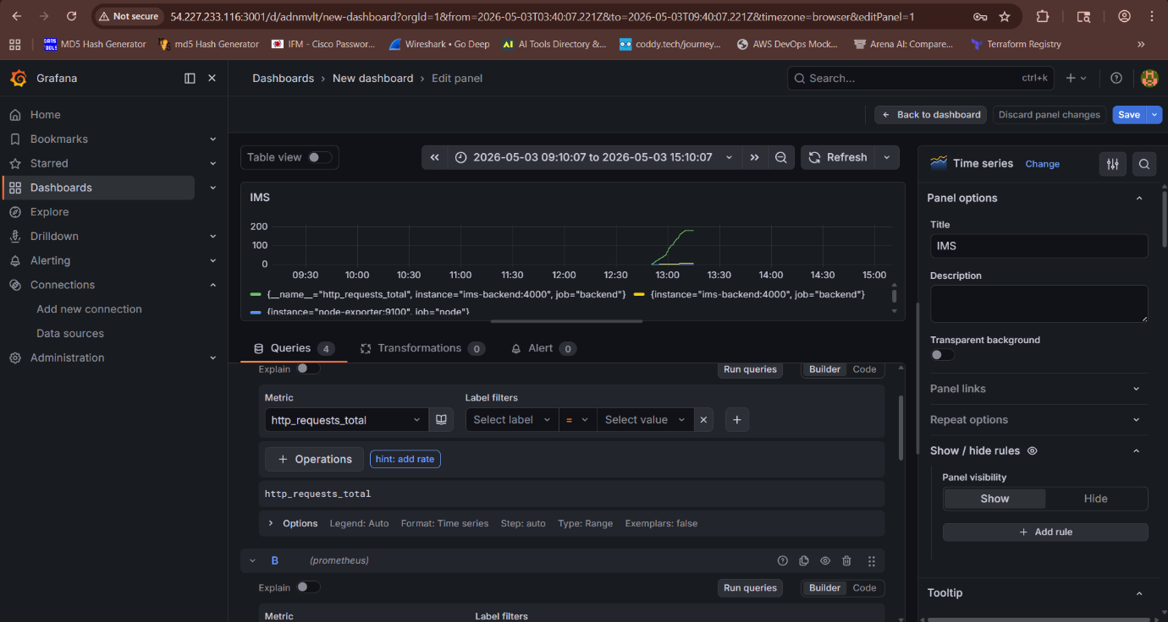
- Prometheus scrapes metrics every 15s from backend and node-exporter.
- Grafana Dashboard Panels:
  - Signal Throughput (rate of signals/sec)
  - Queue Depth (Bull jobs waiting)
  - HTTP Latency (P99 histogram)
  - Open Incidents Count
7. Security & Best Practices
- Rate Limiting: 10k requests/min per IP.
- Input Validation: Required fields enforced at API level.
- CORS + Helmet.js: Secure headers, restricted origins.
- Secrets Management: Environment variables + Jenkins credentials store.
- Trivy CVE Scanning: Fail pipeline on CRITICAL vulnerabilities.
- SonarQube SAST: No blockers/critical hotspots.
- MongoDB TTL Index: Auto-delete signals after 90 days.
- AWS Security Groups: Only required ports exposed.
8. Deployment
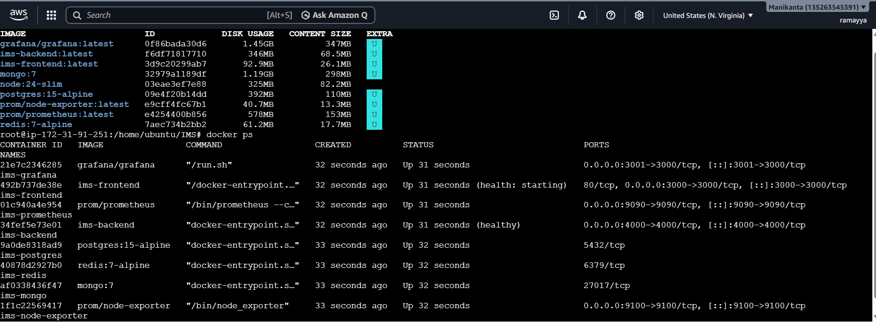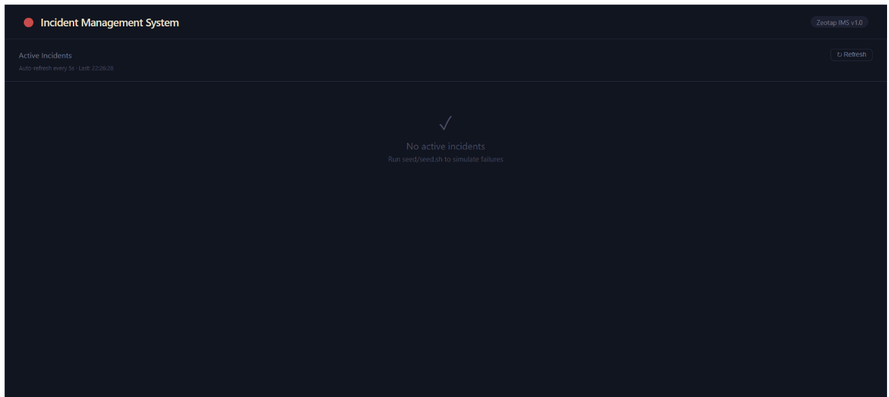
- Local: docker-compose up --build
- Cloud: AWS EC2 (t3.medium) .
- Health Check: curl http://<ec2-ip>:4000/health
- Frontend: http://<ec2-ip>:3000
- Monitoring: Prometheus (:9090), Grafana (:3001).
9. Screenshots (Attached in Submission) link for project screenshots
- Application UI (Incident Dashboard)
- Jenkins Pipeline Execution
- Grafana Dashboard
- Prometheus Targets
- SonarQube Quality Gate Report
10. Conclusion
This project demonstrates SRE capabilities:
- Handling 10k signals/sec with backpressure.
- Enforcing debounce logic and RCA gating.
- Full DevSecOps pipeline with SonarQube + Trivy.
- Observability stack with Prometheus + Grafana.
- Secure, resilient, and scalable deployment on Docker + AWS EC2.

